Lab 1 – Setting Up Flutter and Running Your First App
Exercise 1
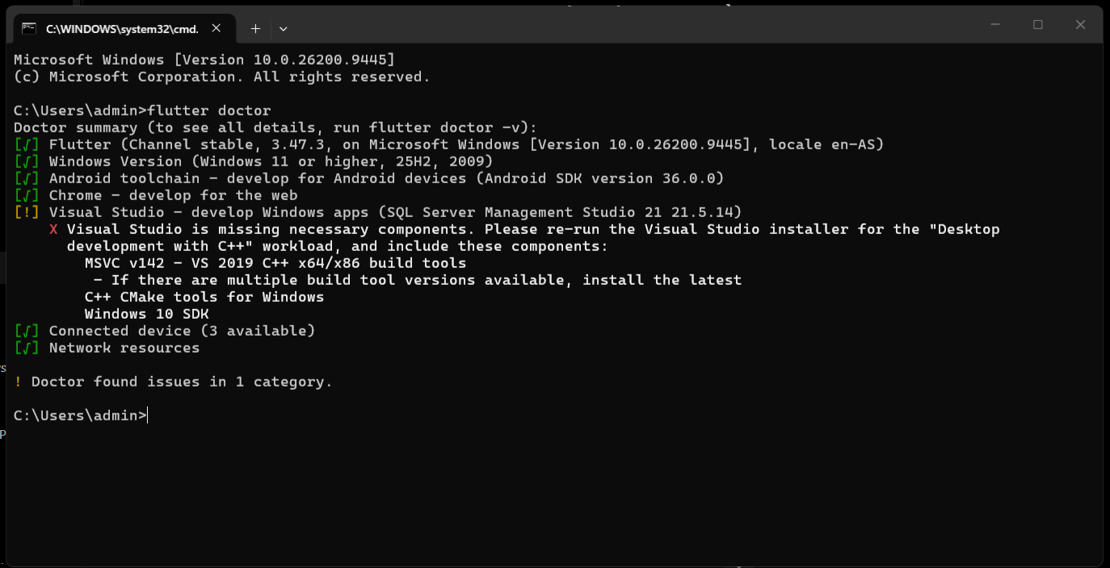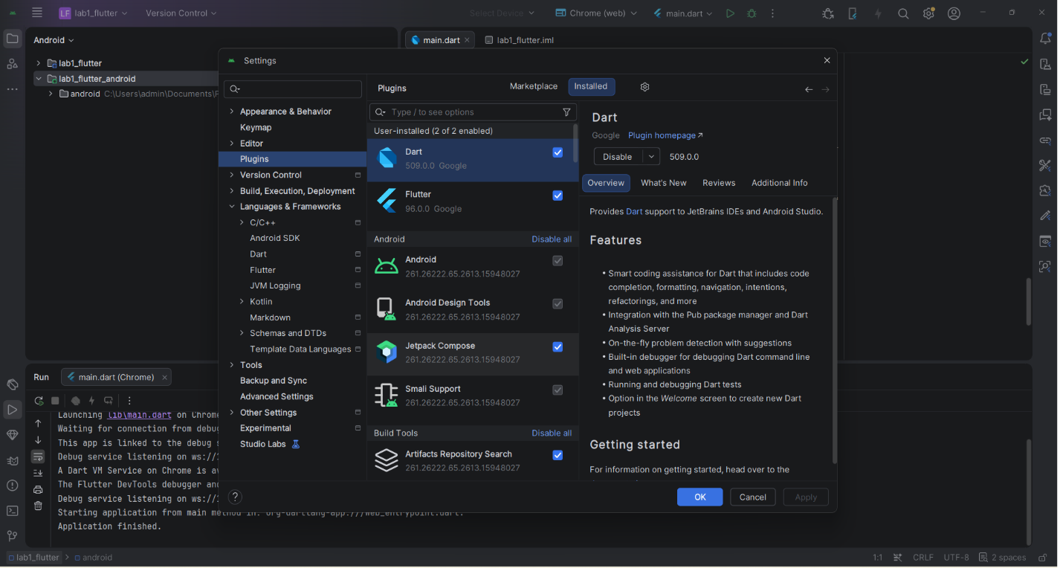

Exercise 2
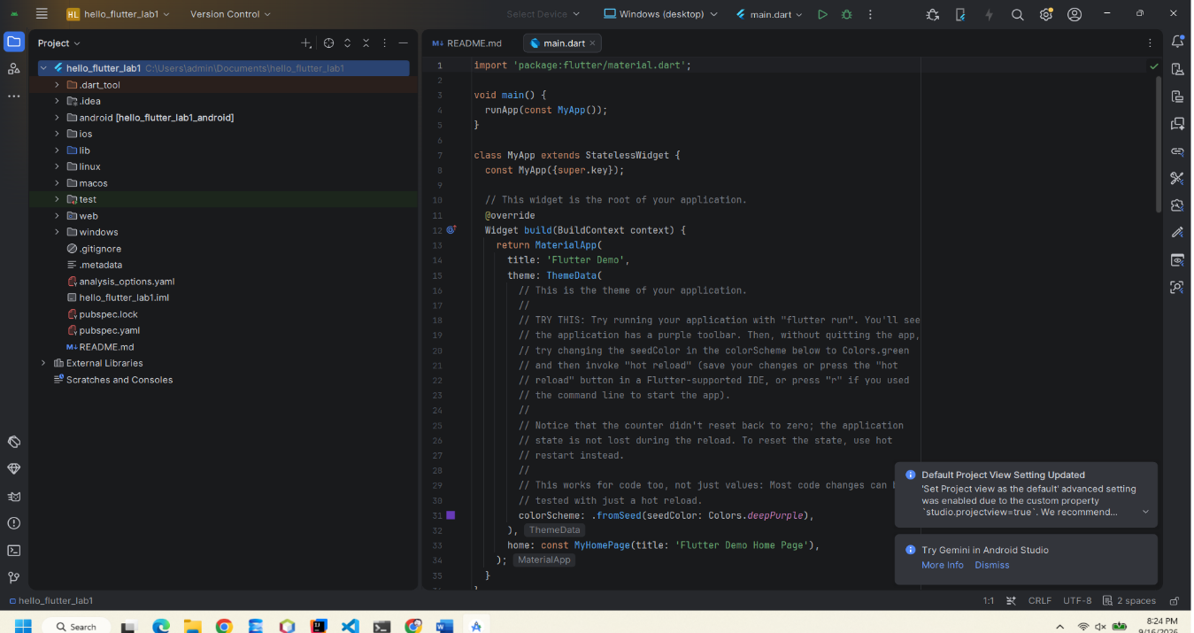

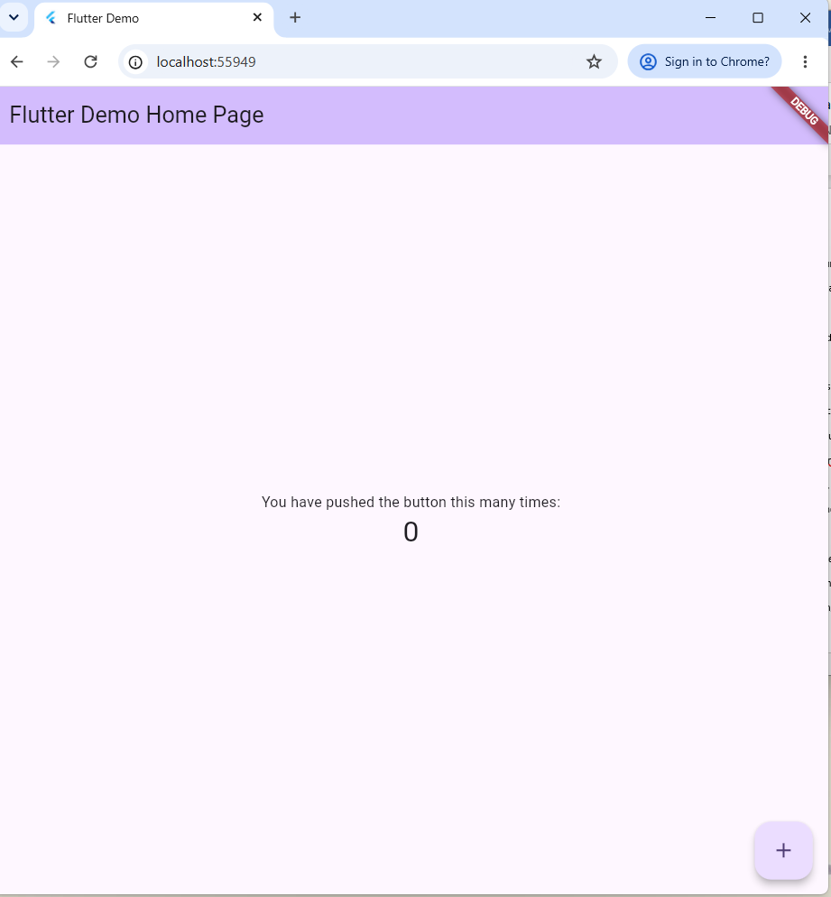
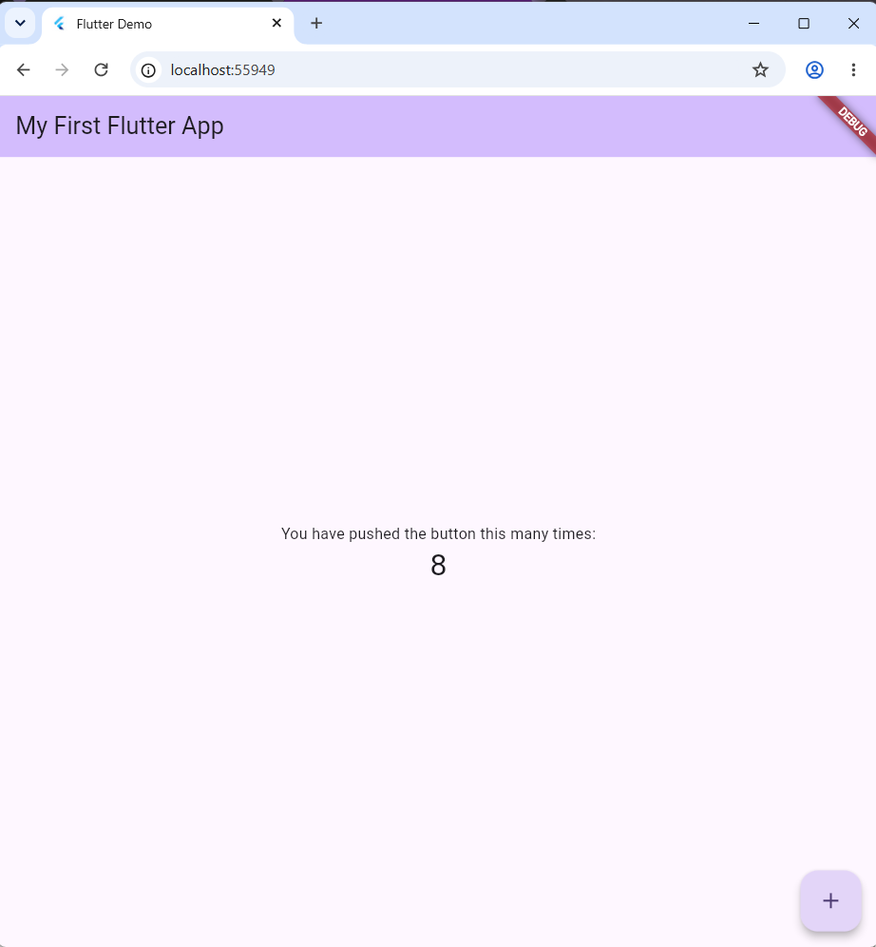

Exercise 3
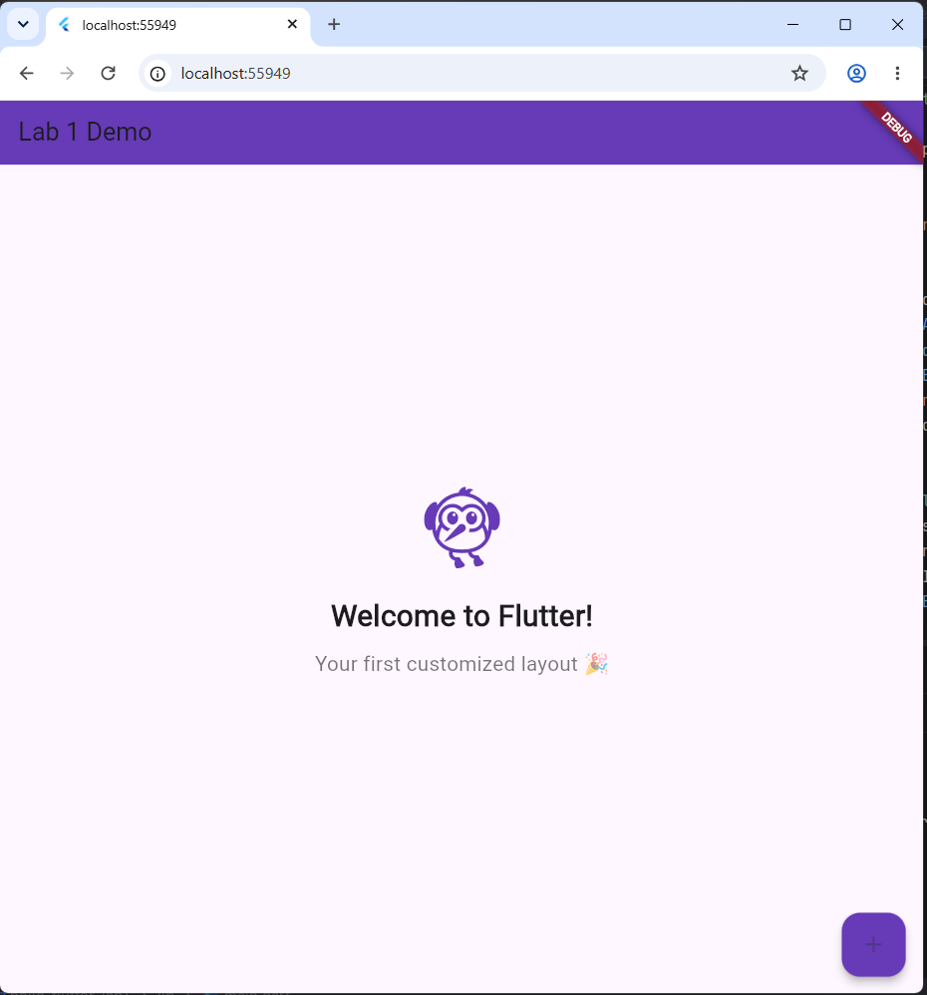
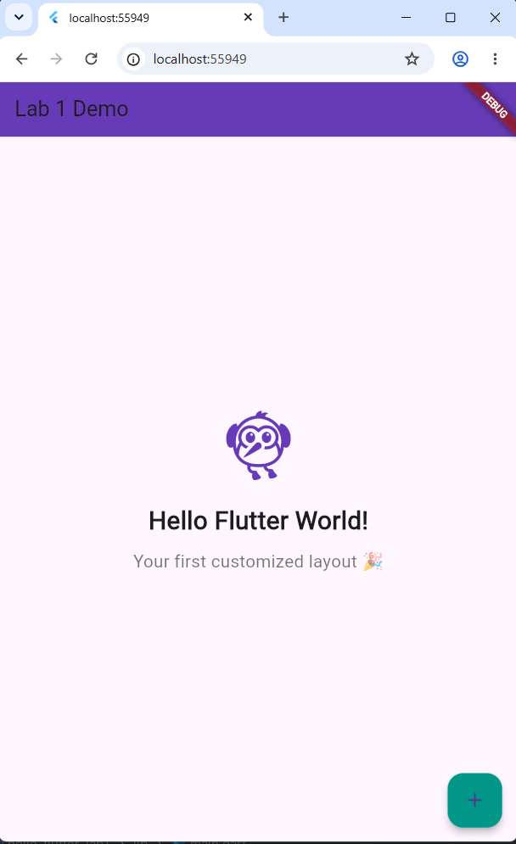

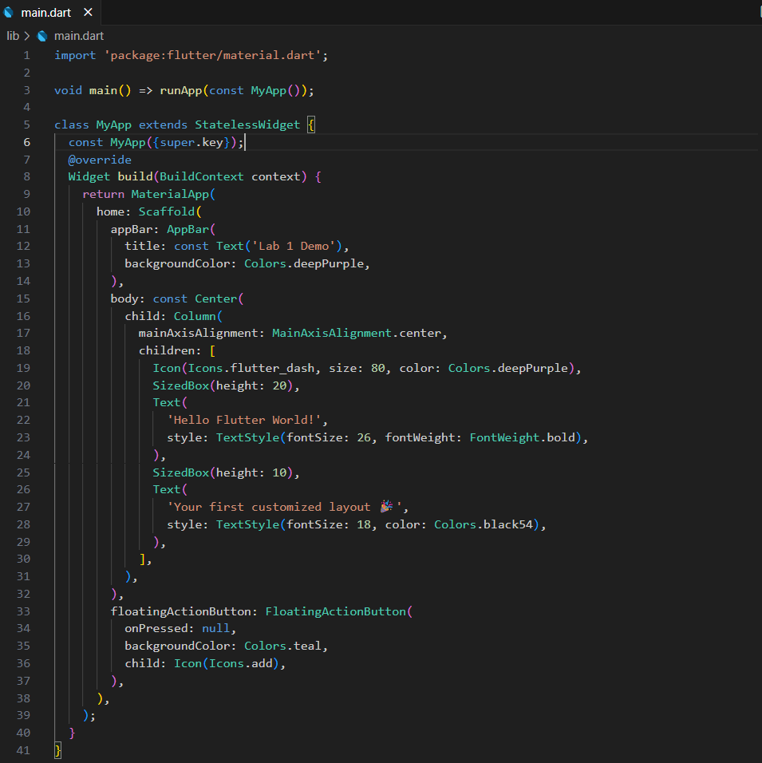
Exercise 4
- What is the purpose of the flutter doctor command?
flutter doctor: Checks whether the Flutter development environment is properly set up (SDK, Android Studio, connected devices, etc.) and reports any missing or misconfigured components.

- What file acts as the entry point of a Flutter application?
Entry point: The file lib/main.dart, specifically the main() function, which calls runApp().
- Explain the difference between Hot Reload and Hot Restart.
• Hot Reload: injects updated code into the running app while preserving the current state; fast.
• Hot Restart: restarts the app from scratch, resetting all state; slower.
- How does runApp() build the widget tree?
How runApp() builds the widget tree: It takes the root widget and attaches it to the screen. The root widget's build() method returns child widgets, which in turn build their own children, forming a hierarchical tree that Flutter uses to render the UI.
- Describe how Flutter’s architecture enables cross-platform development.
Flutter's cross-platform architecture: Flutter renders its own UI using its own engine rather than relying on native platform widgets. It consists of three layers: the Framework (Dart, where widgets/logic are written), the Engine (C/C++, handles rendering and graphics), and the Embedder (platform-specific integration layer). This allows a single codebase to run consistently across Android, iOS, Web, and Desktop platforms.

